**Instruction for the Assignment**

Look for  one example of a curricula from the internet. Curricula can be from any school, any country. Submit  one example here in this module. We will evaluate the curriculum next meeting  
  
**1) Basic education**  
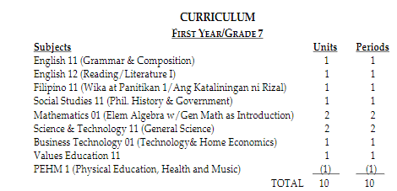

**2.Secondary education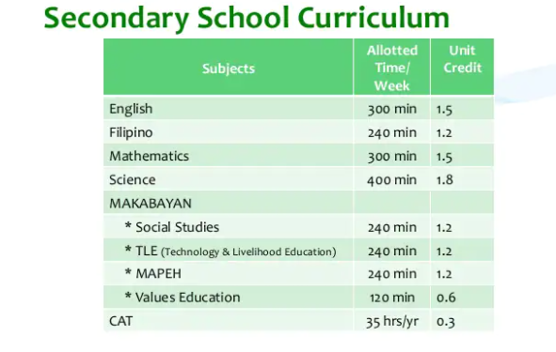2.1.) Middle school/Junior high school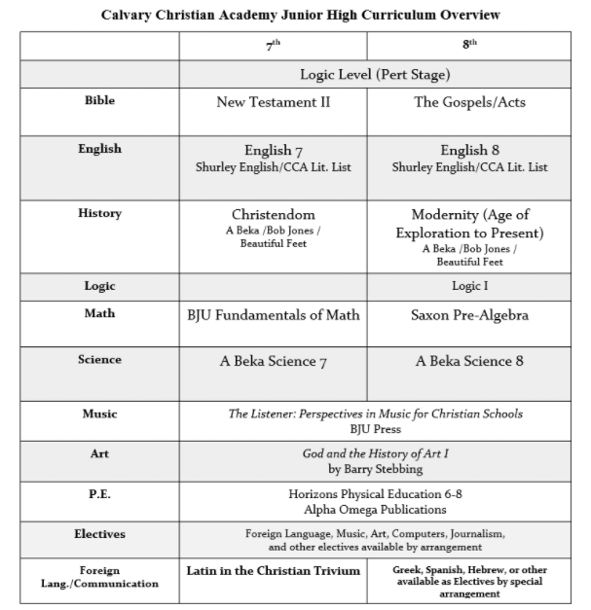2.2.) Senior high school**  
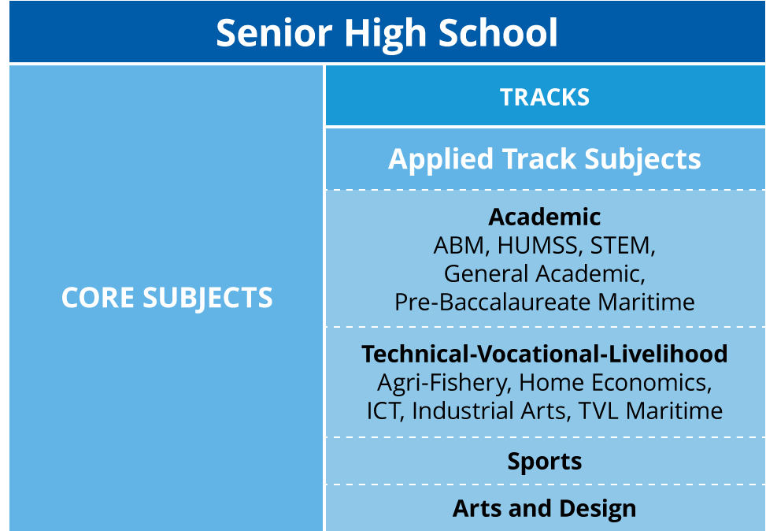

**3.Tertiary education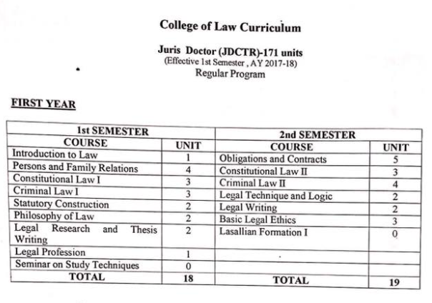 4) Graduate education**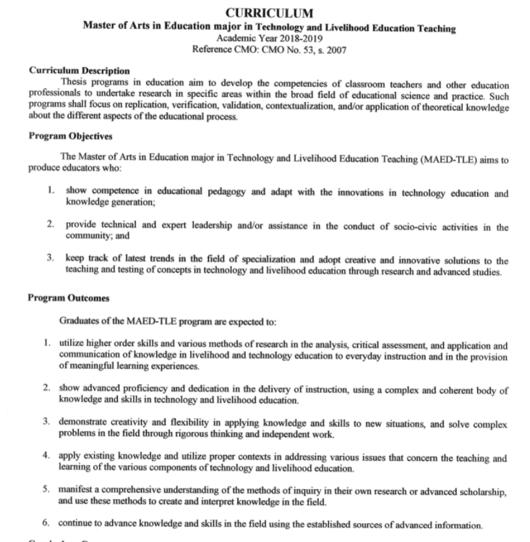  
  
**5) Special education (school for the deaf, children with autism, etc.)**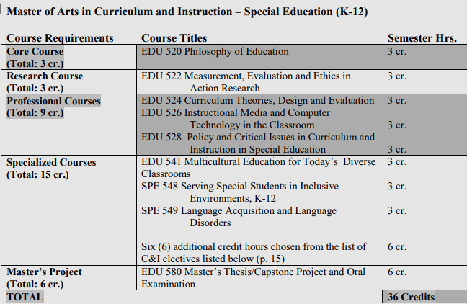  
**6) Global or international education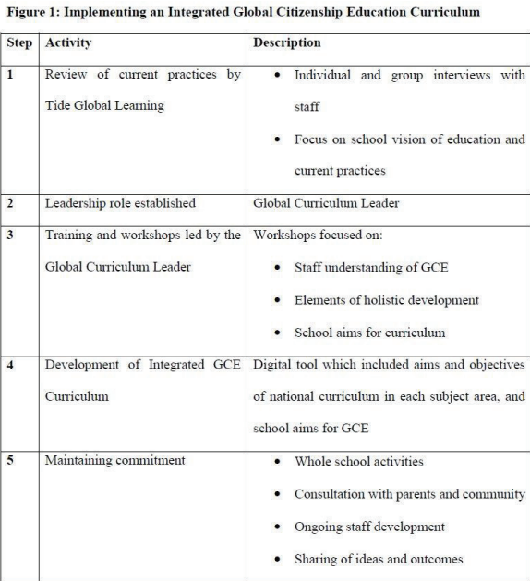 7) Technical -Vocational education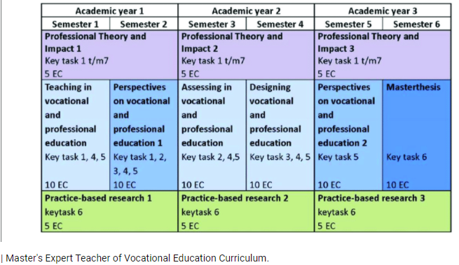 8)** **Public school education**

**School/Yr**

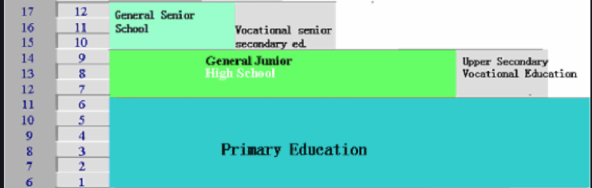

**9) Private school education**

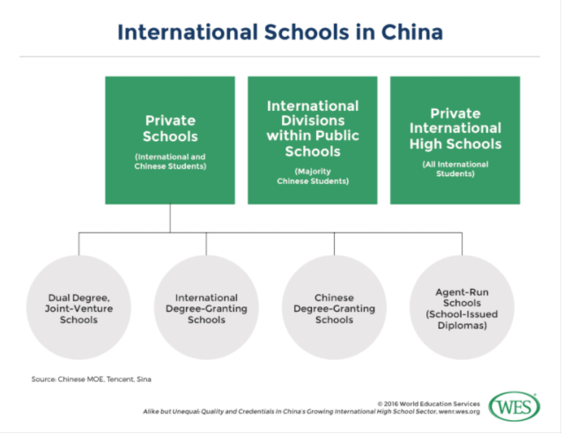

**Refe: https://wenr.wes.org/2016/10/alike-unequal-quality-credentials-chinas-growing-international-high-school-sector  
  
  
  
  
  
  
  
  
10) Religious school (Catholic, Protestant, Anglican, Muslim etc.)**